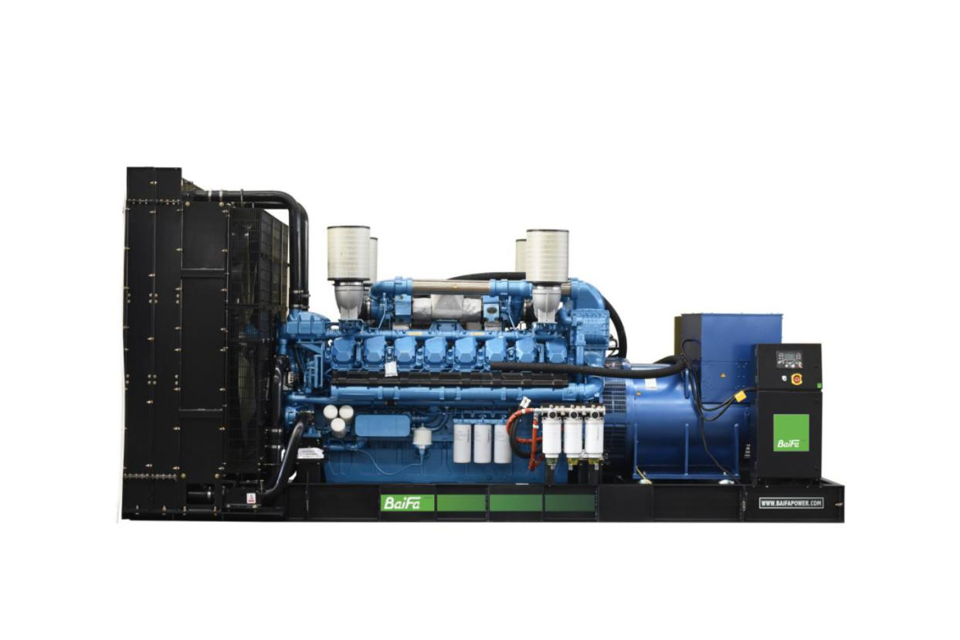

|  |  |  |  |
| --- | --- | --- | --- |
| **ESP**  Standby Power | 2500 kVA | **PRP**  Prime Power | 2275 kVA |
| **Engine** | Baudouin | **Alternator** | STAMFORD |
| 20M33G4D3/5 | S7L1D-H41 |

|  |  |
| --- | --- |
| **GENERAL FEATURES** | |
| Engine: Baudouin 20M33G4D3/5 | Alternator: single bearing, IP23, insulation class H |
| 40℃ radiator, fans are driven by belt, with safety guard | Dry type air filter, fuel filter & oil filter |
| Vibration damper | Standard control panel |
| 24V charging alternator | Exhaust bellows, elbows, flange & muffler |
| Lead-acid batteries, rack and cables | User manual |

|  |  |  |  |  |  |  |
| --- | --- | --- | --- | --- | --- | --- |
| **GENERATOR RATINGS** | | | | | | |
| **Voltage** | **Hz** | **Phase** | **PF**  **（COSΦ）** | **Standby Amps** | **Standby Ratings (kW / kVA)** | **Prime Ratings**  **(kW / kVA)** |
| 440/254 | 50 | 3 | 0.8 | 3280 | 2000kW/2500kVA | 1820kW/2275kVA |
| 415/240 | 50 | 3 | 0.8 | 3478 | 2000kW/2500kVA | 1820kW/2275kVA |
| 400/230 | 50 | 3 | 0.8 | 3609 | 2000kW/2500kVA | 1820kW/2275kVA |
| 380/220 | 50 | 3 | 0.8 | 3798 | 2000kW/2500kVA | 1820kW/2275kVA |

Prime Power (PRP): Prime power is available for an unlimited number of annual hours in variable load application, in accordance with GB/T2820（eqv ISO 8528）; A 10% overload capability is available for a period of 1 hour within a 12-hour period of operation.

Standby Power Rating (ESP): The standby power rating is applicable for supplying emergency power for the duration of a utility power interruption. No overload, utility parallel or negotiated outage operation capability is available at this rating.

|  |
| --- |
| **SALES PROMISES** |

Baifa Power provides a full line of brand new and high quality products. Each and every unit is strictly factory tested.

Warranty is according to our standard conditions: 15 months from the date BAIFA sold to the first buyer or one year after installation or 1000 running hours (accumulated), whichever comes first.

Service and parts are available from Baifa Power or distributors in your location.

|  |  |
| --- | --- |
| **ENGINE SPECIFICATION** | |
| Manufacturer / Model | Baudouin 20M33G4D3/5 |
| Air intake system | Turbo, intercooling |
| Fuel system | High Pressure Common Rail |
| Cylinder arrangement | 20 cylinders in V |
| Displacement | 65.4 L |
| Bore and stroke | 150×185 mm |
| Compression ratio | 15:1 |
| Rated speed | 1500rpm |
| Max. Standby power at rated speed | 2210KW |
| Governor type | ECU |

|  |  |  |
| --- | --- | --- |
| **Exhaust System** | | |
| Exhaust gas flow | 517 m3/min | |
| Exhaust temperature | 550℃ | |
| Max back pressure | 7.5 kPa | |
|  |  | |
| **Air Intake System** | | |
| Max intake restriction | 7.5 kPa | |
| Combustion air flow | 156 m3/min | |
| Air flow required for radiator | 3480 m3/min | |
| **Fuel System** | | |
| Fuel consumption @ 100% (Prime Power) Load | 199g/kWh | 462 L/h |
| Fuel consumption @ 75% (Prime Power) Load | 192g/kWh | 338 L/h |
| Fuel consumption @ 50% (Prime Power) Load | 196g/kWh | 237 L/h |

|  |  |
| --- | --- |
| **Oil System** | |
| Total oil capacity | 240L |
| Oil consumption ratio based on fuel consumption data | ≤ 0.3 % |
| Oil sump capacity | 210-240L |

|  |  |
| --- | --- |
| **Cooling System** | |
| Coolant capacity | 410L |
| Max water temperature | 103℃ |

|  |  |
| --- | --- |
| **ALTERNATOR SPECIFICATION** | |
| Industrial alternators meet the requirements of the relevant parts of the BS5000, VDE 0530, NEMA MG1-22, IEC34, CSA 22.2-100 and AS1359. | |
| **Alternator Data** | |
| Number of Phase | 3 |
| Connecting Type | 3 Phase and 4 Wires, Y type connecting |
| Number of Bearing | 1 |
| Power Factor | 0.8 |
| Protection Class | IP23 |
| Altitude | ≤1000m |
| Exciter Type | Brushless exciting |
| Insulation Class/Temperature Rise | H/H |
| Telephone Influence Factor (TIF) | ＜50 |
| THF | ＜2% |
| Alternator Capacity | 2325kVA |
| Alternator Efficiency | 96.2% |

|  |  |
| --- | --- |
| **GENERATING SET DATA** | |
| Related range of voltage setting | ≥±5% |
| Steady-state voltage deviation | ≤±1% |
| Transient voltage deviation (100 % sudden power decrease) | ≤+20% |
| Transient voltage deviation (sudden power  increase) | ≤-15% |
| Voltage recovery time (100 % sudden power decrease) | ≤4S |
| Voltage recovery time (sudden power increase) | ≤4S |
| Related range of frequency setting | 0-5% adjustable |
| Steady-state frequency band | ≤0.5% |
| Transient frequency deviation (100 % sudden power decrease) | ≤+10% |
| Transient frequency deviation (sudden power increase) | ≤-7% |
| Frequency recovery time (100 % sudden power decrease) | ≤3S |
| Frequency recovery time (sudden power increase) | ≤3S |

|  |  |  |
| --- | --- | --- |
| **STANDARD FEATURES** | | |
| Standard auto control system | Exhaust system (including until muffler) | Documents |
| Oil drain valve | Starting batteries (maintenance-free & watering-free) with connective wires |  |
|  |  |  |

|  |  |  |
| --- | --- | --- |
| **OPTIONS** | | |
| Daily fuel tank | Rainproof type | Remote control panel |
| Alternator heater | Soundproof type | Paralleling system |
| Spare parts | Trailer type | Switch box |
| Automatic transfer switch |  |  |

|  |  |
| --- | --- |
| **DIMENSIONS & WEIGHT** | |
|  | **Standard Configuration (open type)** |
| Overall Dimensions: 6250×2320×2600 mm |
| Weight: 15300 kg |
|  |
|  |
|  |

*Specifications are subject to change without notice.*

**BAIFA POWER (WUXI) LTD.**

**Website: www.baifapower.com**

**Email: marketing@baifapower.com**

**Tel: +86-510-85342633**